29909732

Thabo Mponya’s Technical CV website.

Technology used:

The website was built using React.js and is brought to life using a handful of React libraries;

1. React-router-dom for routing. A route table was set up in the App.js file to allow navigation.

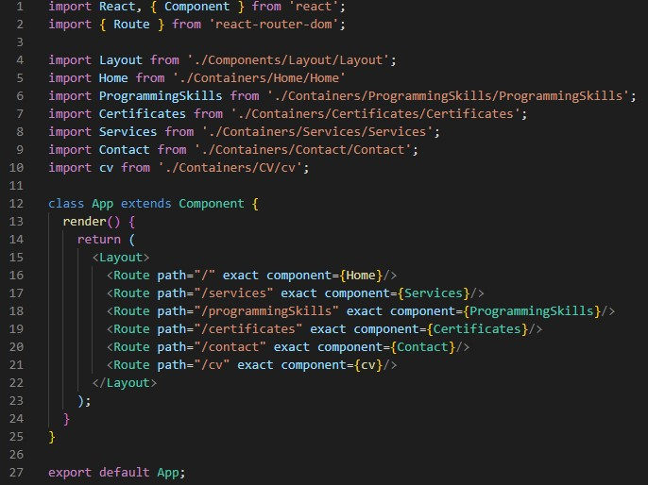

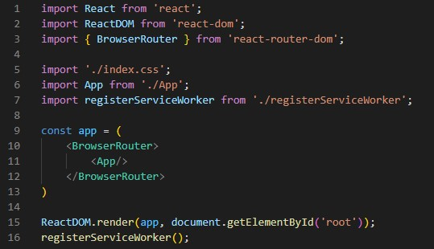

1. Emailjs for sending emails on the site. Since the email is sent through the Contact.js page, the algorithm that called for the EmailJs library was written in that file.

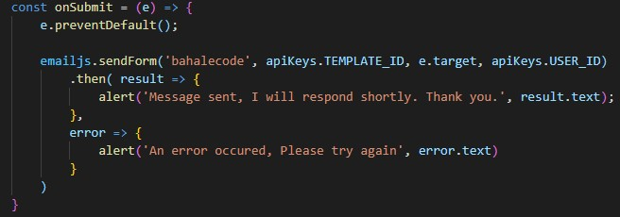

Styling:

For styling, every JavaScript component that required styling had a css file to reference the styling.

Functionality:

The Home page’s background is fully functional only in Microsoft Edge, however, in Firefox and chrome, it is not.

Firefox:

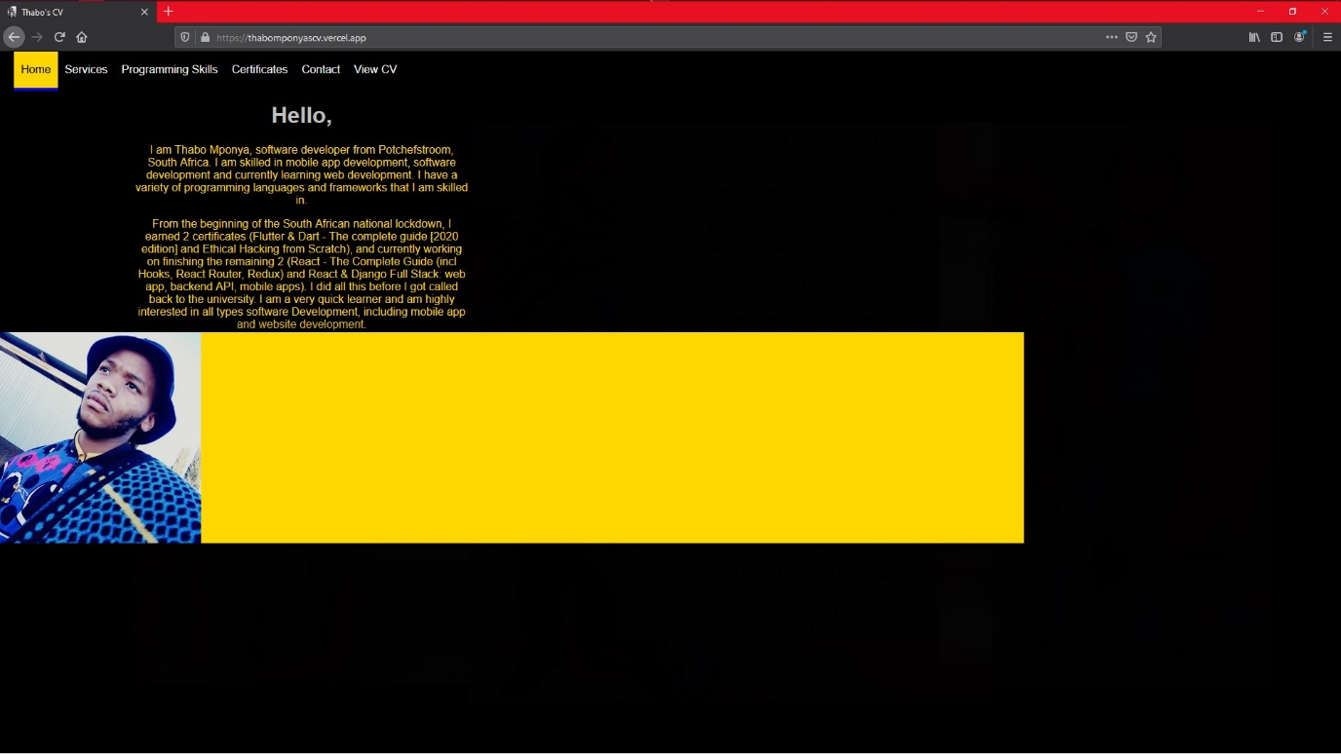

Microsoft EDGE:

